Utilizing the PerfectServe Camera for HIPAA Compliant Image Sharing
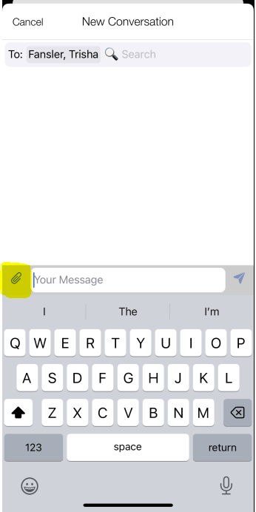

After beginning a New Conversation and selecting the practitioner or care team member you wish to contact, Click the paperclip in the upper left section of your phone’s keyboard.
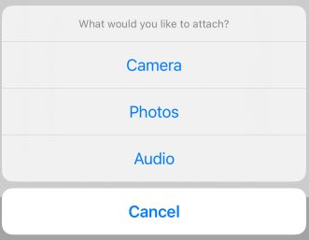
Use the CAMERA option as it ensures that any image that is shared or consulted upon is not stored to a device.
Do not use the PHOTO option.
Remember: Always ensure that informed consent is obtained from the individual before capturing, sharing, or consulting on images containing sensitive health data.

